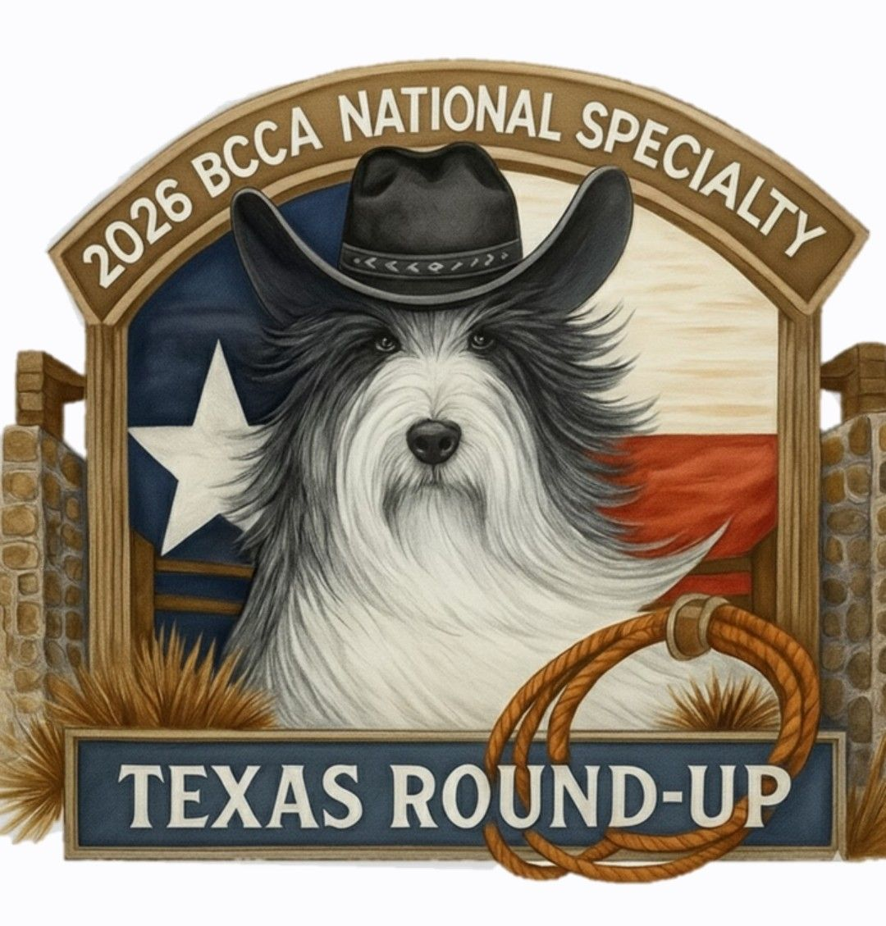

2026 National Specialty Trophy Fund Request Form

Whether you’re planning to attend the BCCA National Specialty in Garland, TX this fall or not, you can still play an important part in the coming Specialty. Just visit the Trophy Sponsorship page on bcca2026.com, check out the available trophies on the spreadsheet, and choose the award(s) you'd like to sponsor. If you want to, you may make this donation in memory of a departed Beardie, friend, or family member, or in honor of a living dog or person. Simply fill in below the award(s) you want to sponsor and complete the dedication section. We hope you will also consider a donation to the General Trophy Fund. You have until August 6, 2026 for your sponsorships to appear in the catalog.

Award Donation Dedication

_____________________________________________________________________________________________

Donation for General Trophy Fund ____________________

Total: ____________________

Please make your check payable to “2026 BCCA National Specialty” and send it with a copy of this form to:

Courtnie Eastman, P.O. Box 708, Wauna, WA 98395

OR check here _______ if you would prefer to receive a PayPal invoice.

