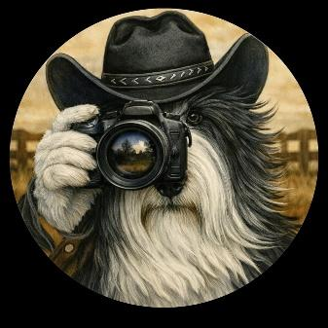

2026 Digital Photo Contest

Entries are now being accepted for the 2026 photo contest. The photos will be displayed in the hall of the Host Hotel (Near the Vendors Area) for everyone to see.

You will also have the opportunity to cast your vote for your favorite shot – as we will be selecting “People’s Choice” award.

Entries close on September 6th, 2026
JUDGE: Taylor - Dog Win Photos

Event Chair:
Martha Fruehwald – bccatexas2026@yahoo.com
6534 Hess Rd
Vassar, MI 48768

PHOTO ENTRIES
Amateur photos only. No professional ones, please.

All photos must be of Beardies. No humans in the pictures, please. (See ** exception below)
All entries must be submitted via email as an attachment or submitted via snail mail on a CD.
Please tag each photo with category and caption.

CATEGORIES

There are SIX categories for your photos

We are very excited to announce a brand-new category for this year:

**BEARDIES & Their Buckaroos
Kids up to 12 years old with their beloved Beardies doing what they do best together – enjoying life to its fullest.

Happy Trails & Flying Tails
Beardies doing what Beardies do best: Exploring.
This can be Beardies playing in the leaves, water, mud, snow. Hiking or visiting unusual places.

Shaggy Mugshots
Headshots depicting the Beardie personality and the beauty of the breed.
Look for shots where the eyes convey Beardies intelligence and gentle nature. The best head shots will showcase their signature fluffy appearance while allowing their engaging and intelligent eyes to shine through, reflecting their kind and boisterous personalities. (no show photos, please)

Hold Onto Your Hat
This is a shot displaying our Beardies athleticism. Happy fur and bounding energy, Beardies epitomize joy in motion – We want pictures showcasing the playful spirit and tireless energy that makes them such active companions. This can be herding, running, jumping, diving, swimming, etc.

Wild West Wiggles
This is a shot of your Beardie doing something funny or being silly and makes you LAUGH OUT LOUD.

Beyond the Barn Door
This is a creative shot. To capture the Beardies spirit in a truly "out-of-the-box" way. Consider images that go beyond a typical posed portrait. The more unusual the better. Use your creativity and imagination.

ENTRIES AND FEES
You can submit up to three photos per category.
There is a $5.00 fee per photo submitted.
Your photo fees can be:
Checks - mailed to Martha’s address.
Martha Fruehwald
6534 Hess Rd
Vassar, MI 48768

Make checks or money orders payable to BCCA.

PayPal - bccatexas2026@yahoo.com

ALL PHOTOS MUST……

- Be of good, clear quality (black and white or color).

- Be 300 dpi at a minimum size of 5 X 7 inches

- Include creative photo category and caption.

Images should be submitted in JPG format.
Digital Manipulation is allowed as long as it is minor adjustments like cropping and color correction.
(See Release Form)
Do not reduce resolution for e-mailing. Photos which are not viewable for any reason will be rejected.
The contest chair will acknowledge receipt of your entry by e-mail.
Digital images will not be returned.

FORMS

- Contest entry form
- Photo release form
- Contest rules

AWARDS

Ribbons will be awarded by category for 1st, 2nd, 3rdplace
Best of Show Ribbon and special prize
People’s Choice Award Ribbon and special prize.

